# The Watcher

Purpose: To monitor important tables throughout the enterprise and alert of data loading failures/issues

#### Solution:

##### Database Level

Server: SQLDW

Database: Utility

Schema: Watcher (views, tables and columns)

###### Application Level:

G:\artifacts\dev\com.pharmmd.com.TheWatcher

G:\artifacts\prod\com.pharmmd.com.TheWatcher

#### Structure:

This is currently defaulted to looking back 2 days at a particular date column on a table (this should typically use a column with a getdate() default). The configuration table uses the following columns to run a dynamic SQL query to check the desired table.

NOTE: The Date Interval is now a configurable value via the table (7/26/2018)

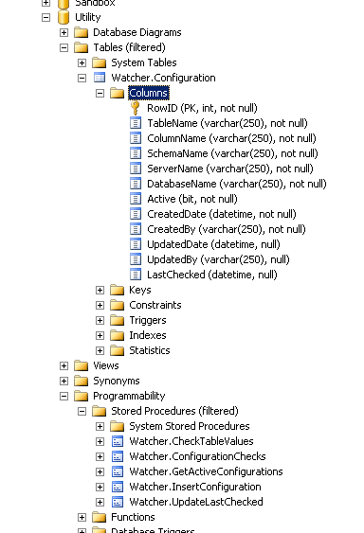

Figure 1. Watcher configuration

The email notification person is listed in the application’s app.config file and will receive an email alert on failure.

The Watcher has 3 modes. One is a basic sql query (mode=3). One checks for the existence of any data in a column (mode=2). The last one uses a standard date field for checking the number of days since an update (mode=1).

Version History

|  |  |  |
| --- | --- | --- |
| Version | Notes | Date |
| 1.0 | Creation | 7/6/2018 |
| 1.1 | Update for new mode for dynamic sql queries and testing | 10/25/2019 |